Daily Linux Hands-On Lab – Part – 3

1.Demonstrate about Linux security (e.g., iptables, ufw, and SELinux).

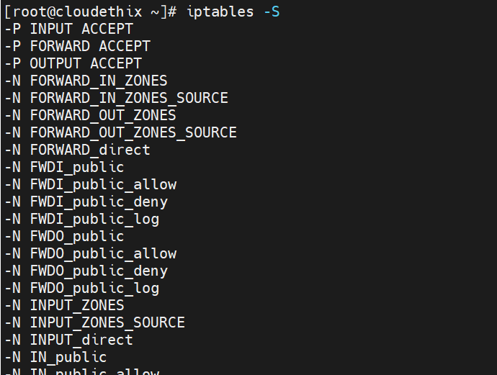

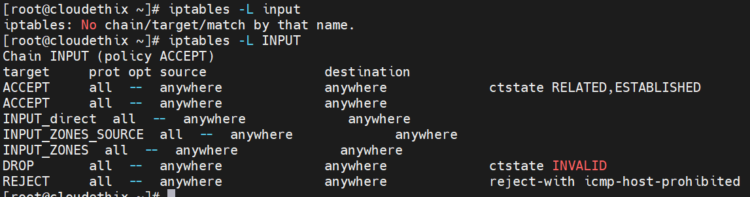

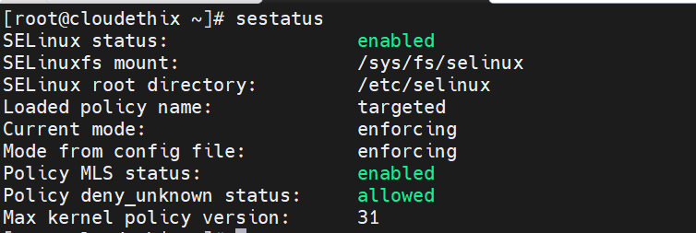

2. Demonstrate using text processing commands (e.g., grep, awk, sed,
sort, cut, paste, tr).

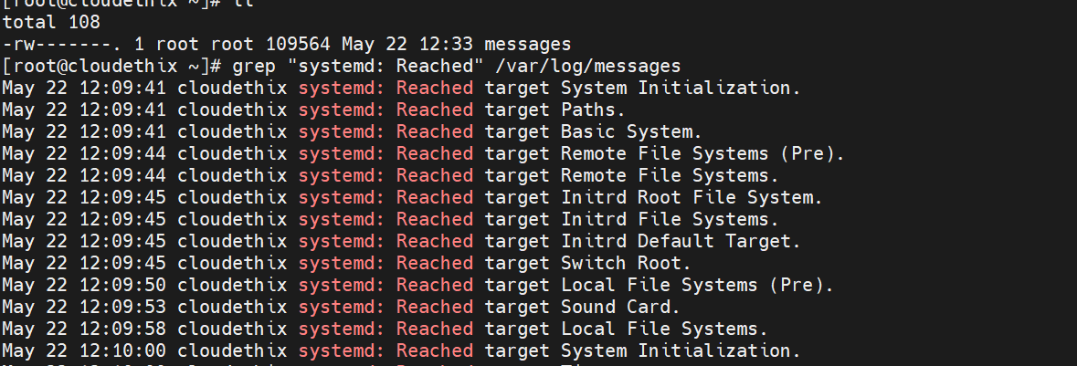

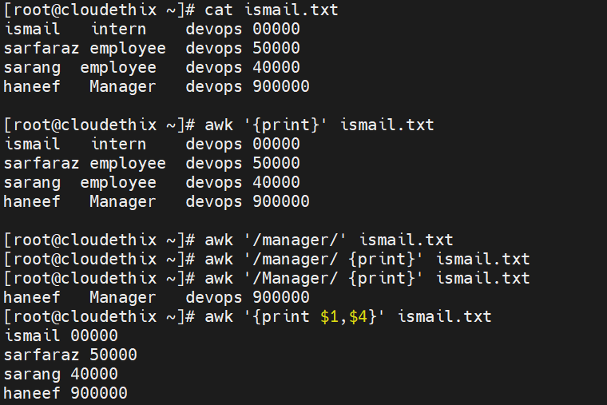

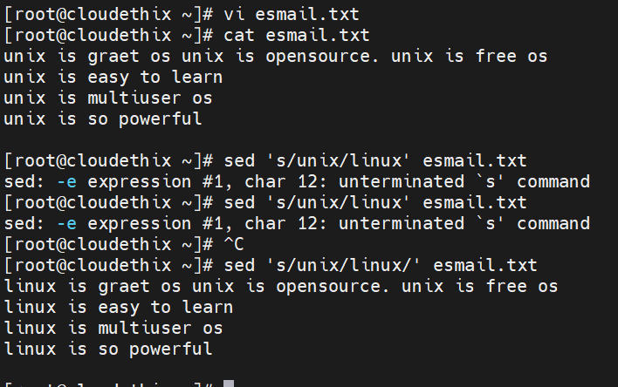

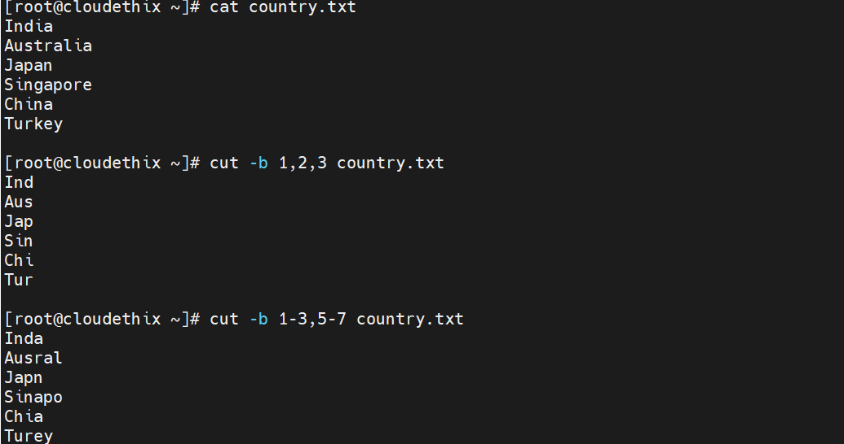

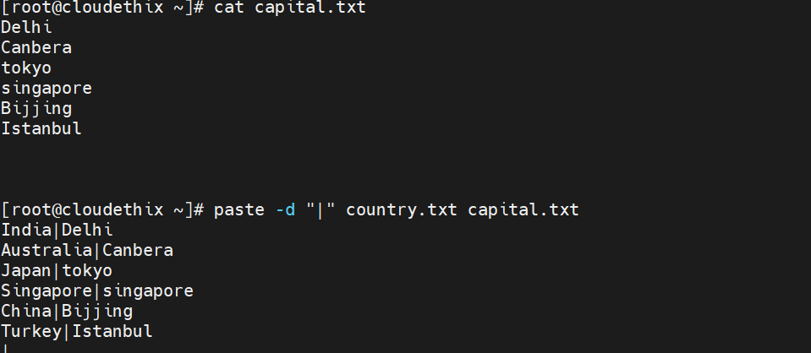

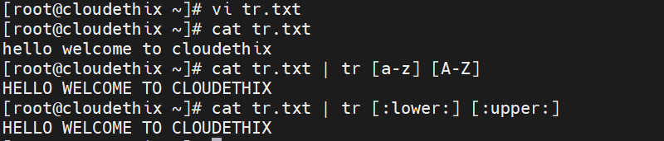

3. Set up a basic file server using NFS. Mount NFS on 2 Linux boxes.
Partition should get mounted even after reboot.
1.Installing nfs-utils
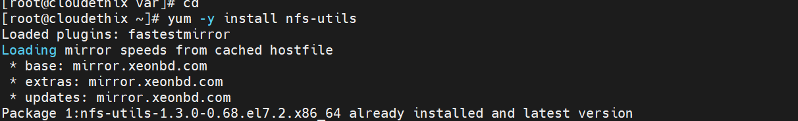

- Choose the directory to share. If not present create one.
3.Add permissions and ownwership privilages to the shared directory.

4.Start the nfs services.

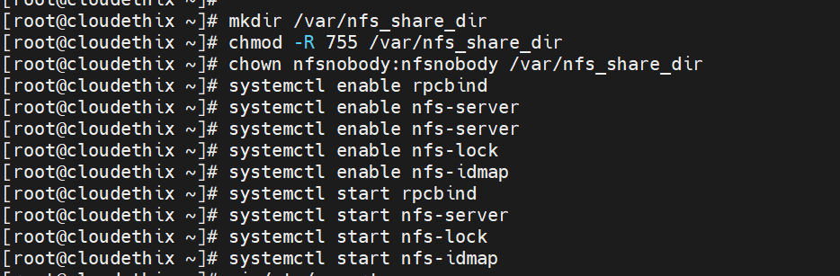

- Configuring the exports file for sharing.
Open the exports file and add these lines.
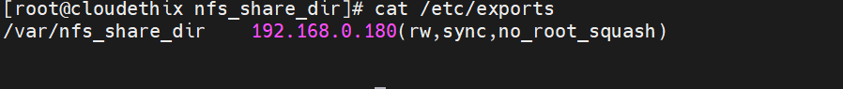

6.Restart the service

Setup NFS-Client(s)
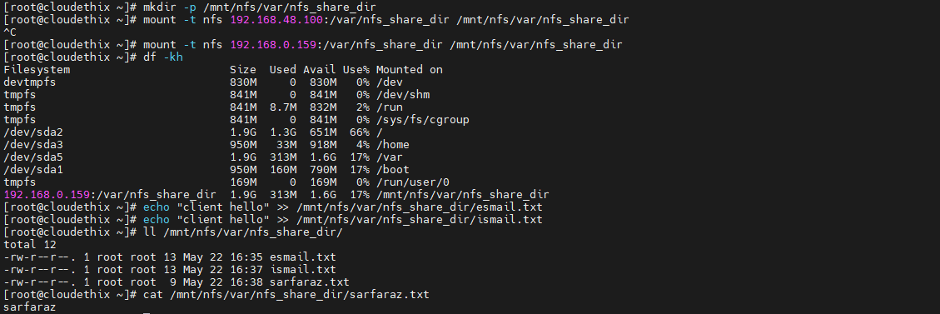

Server-side(192.168.0.159)
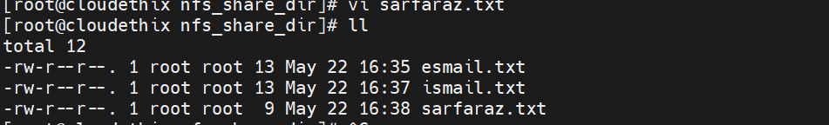

4.Demonstrate about system backup and recovery (e.g., rsync, dd, SCP). Use multiple Linux machines

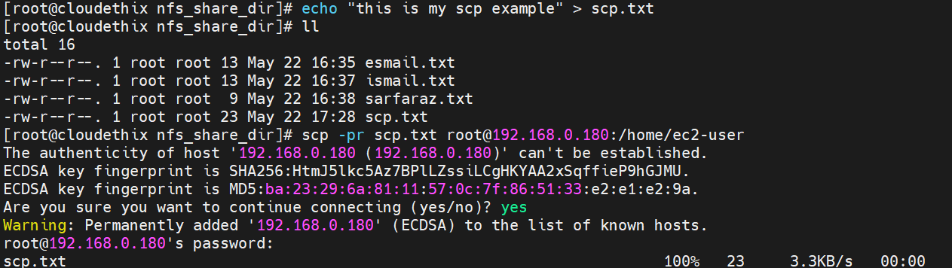

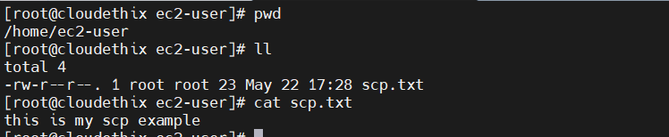

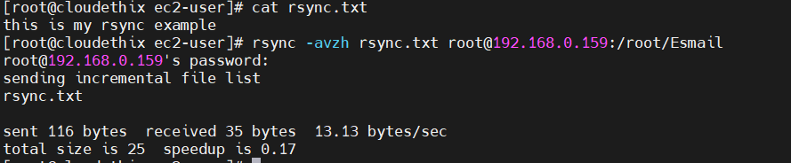

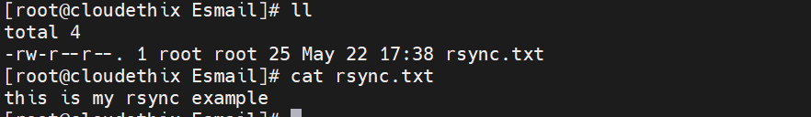

5.Familiarize yourself with performance monitoring tools (e.g., iostat, vmstat, and SAR). Enable it & demonstrate the same.
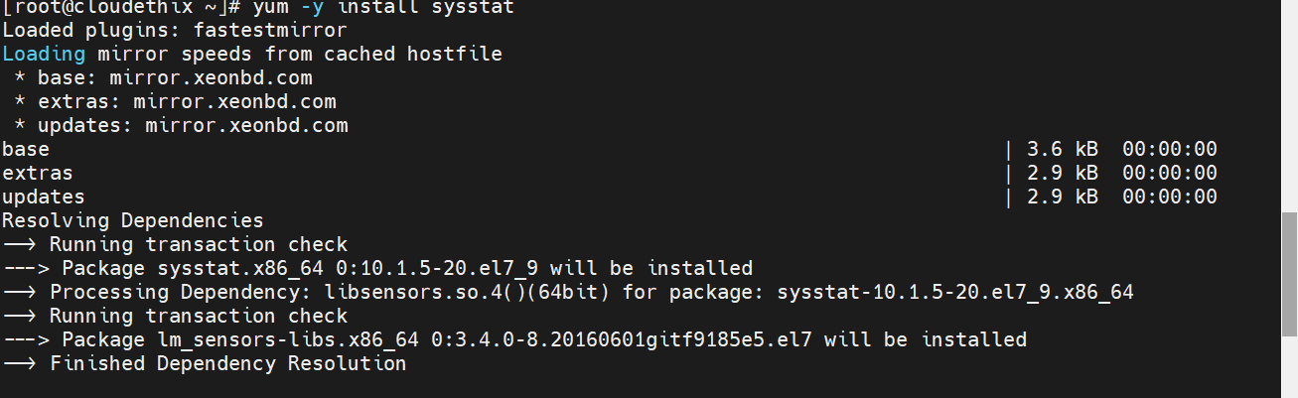

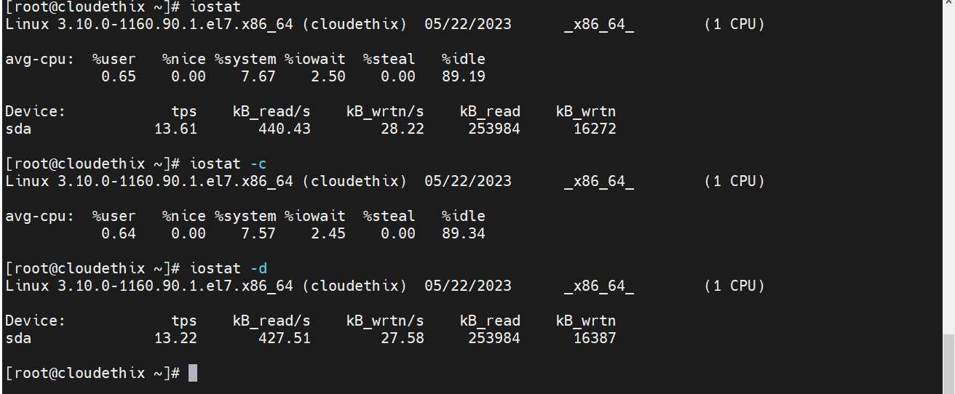

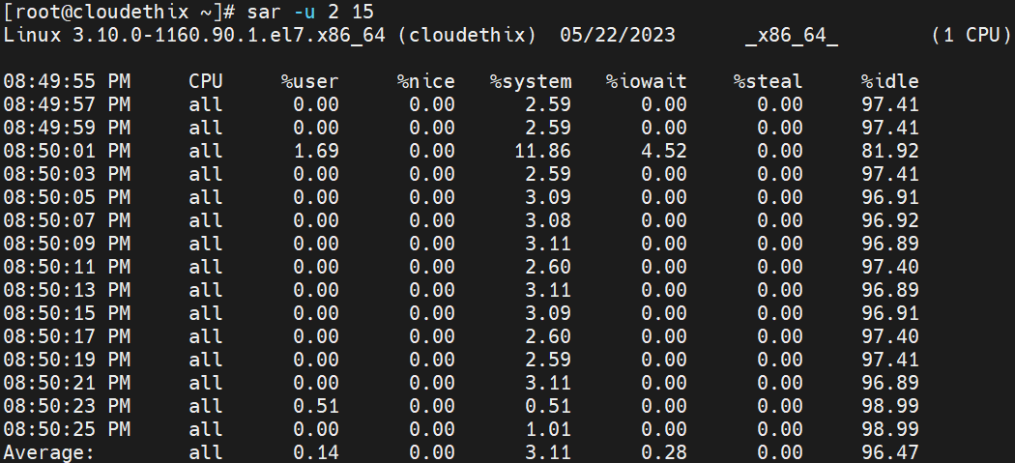

- Add 2GBSwap in Linux from File.
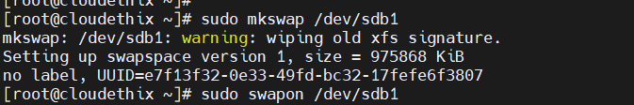

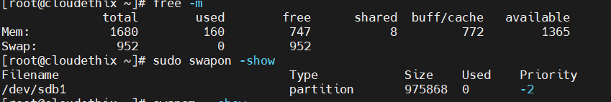

- Add LVM Disk, Resize LVM, And Reduce LVM & Remove LVM? Demonstrate it.
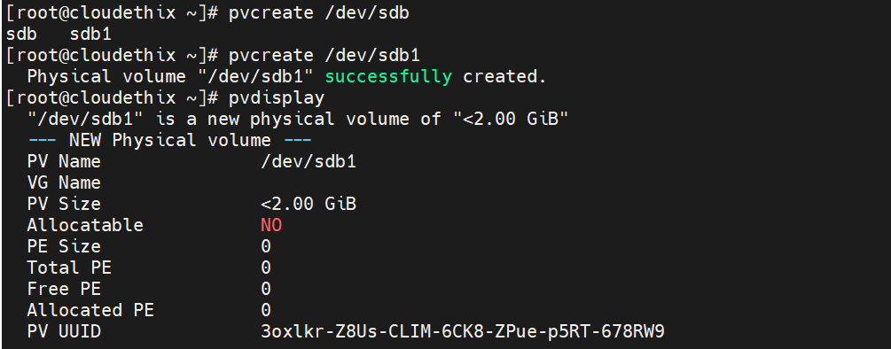
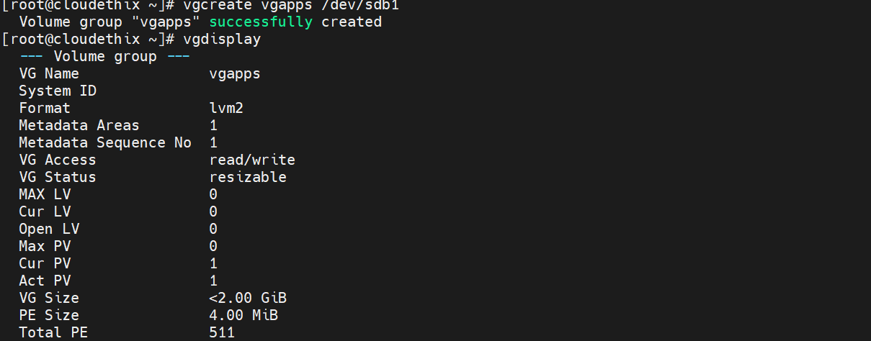
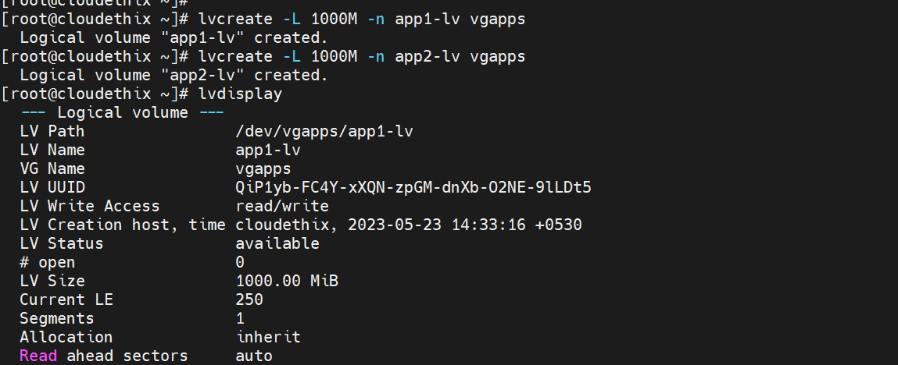

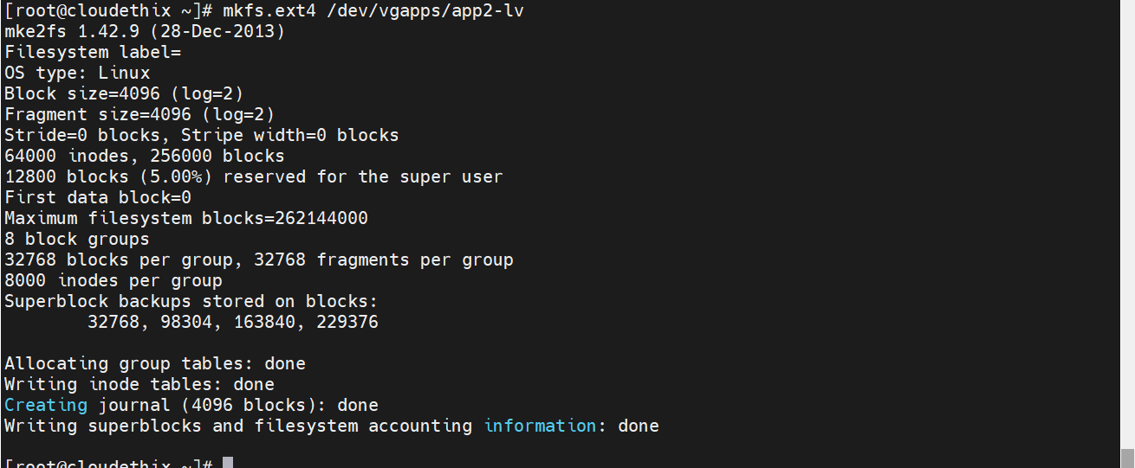

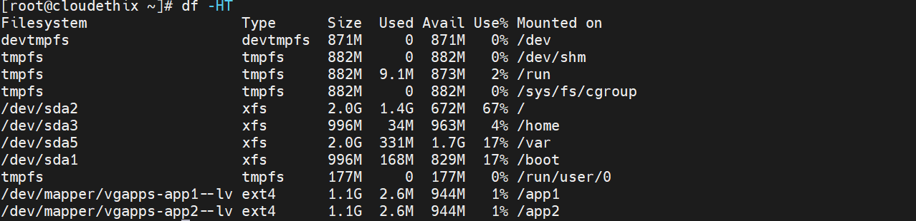

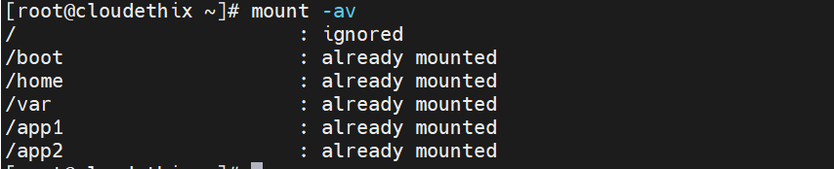
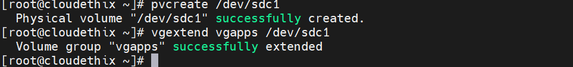
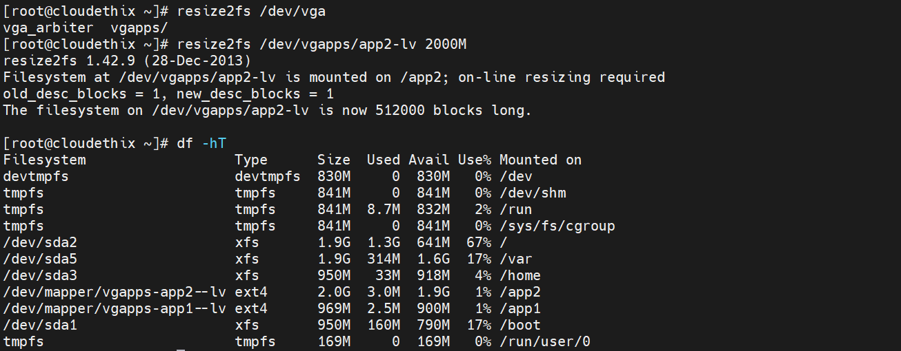
- Create 1 AWS instance, SSH from Key, change permission of /home/ec2-user to Chmod -R 777, Logout, try login, recover it by mounting the disk to another EC2 instance. V1:
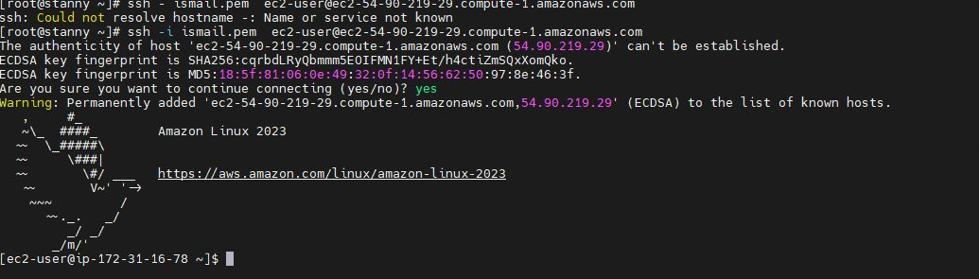
- Print all common port numbers (min 10) in Linux using echo command ? Demonstrate the same.
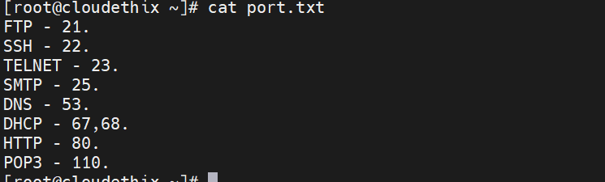

10. NIC Bonding or Teaming in Linux? Demonstrate the same.
